LGE Internal Use Only

SW Coding Rules Guide

About This Document
Document Information
Issuing authority | VS SW Process Unit
Status of document | In Progress / Approved / Released

Revision History
Version | Date | Comment | Author | Approver
2.0 | 2021-09-02 | As the SW Architect Unit provides/operates the coding rule and code review guide through the collab site, the link is provided in this document.  * Since the guide content itself is redundant, it is not provided in this document, but only provided by Collab. | JungSoo Hwang,  (SW Architect Unit)  Sookyung Yoon  (SW Process Unit) | SW Process Unit Leader

1 Coding Rule

Coding style and rules and code review related guides are provided at the following collab site.
- http://collab.lge.com/main/pages/viewpage.action?pageId=1420976140

Please check the following information in the above collab.
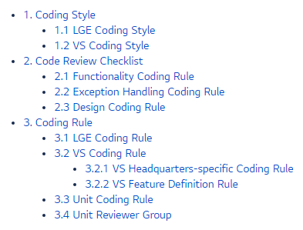

NOTE
For MISRA-C, MISRA-C++, MISRA Deviation Report guide, see the collab as below.
http://collab.lge.com/main/pages/viewpage.action?pageId=614447714

